## Supplementary Sheets

In regard to the project report submitted above, we have added a few more plots in the supplementary sheet that would provide some additional insight on the comparative study of the prediction of term deposits using Logistic Regression in all the four languages – Python, R, SAS and Minitab.

Results

In the following section we have provided the ROC curves for R, SAS and Minitab. An ROC curve shows the performance of a classification model at all the thresholds.

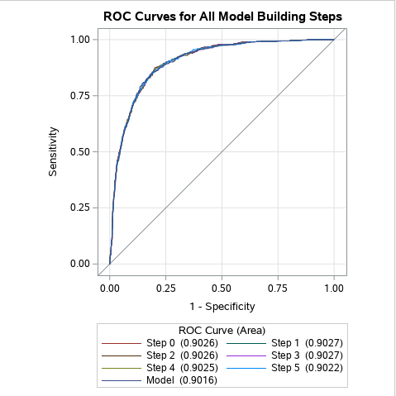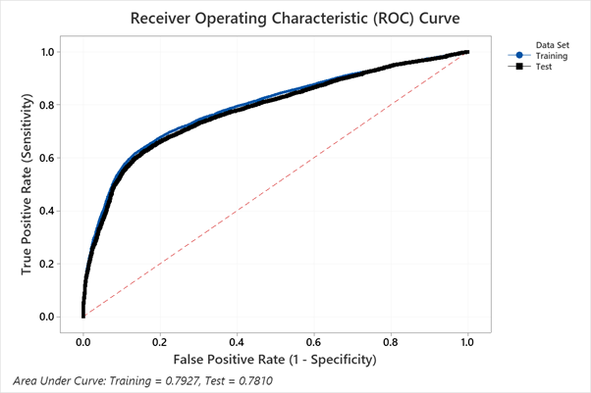

Figure 2 - ROC Curve - SAS

Figure 1 - ROC Curve - Minitab

Figure 3 - ROC Curve - R

|  |  |  |  |  |
| --- | --- | --- | --- | --- |
| Languages/Results | Accuracy | Precision | Sensitivity | Specificity |
| Python | 0.8777 | 0.9723 | 0.2036 | 0.9723 |
| R | 0.8699 | 0.8590 | 0.8578 | 0.8821 |

Table 1 - Output Results

Codebase

The codebase for the project is hosted on GitHub and can be downloaded from [here](https://github.com/aveek22/mu_st_661_final.git).